CURRICULUMN VITAE

[FULL NAME] Professor LAW, Wai Hung Francis |  |  |  |  | 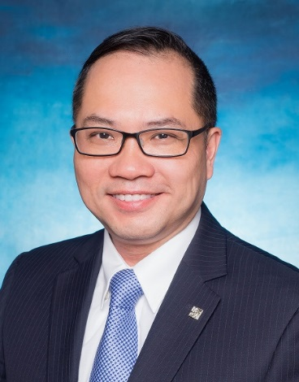
 | Date of birth: 7 January 1966
 | Professional Dispute Resolution Expert
 | Flat E 27/F Tung Ting Mansion, Taikoo Sing Hong Kong
 | 825-67733698 |  |  | 852-28661299
 | Email: francislaw.mediation@yahoo.com.hk
 | Professional specialty. International Trade, Intellectual Property, Construction and Financial
 | Fluent in Cantonese, English and Putonghua
Education
Qualifications |  | Master in Business Administration, Honorary Doctorate in Law
Major(s) |  | Business Administration and Law
University(s) |  | University of Leister, UK. & Sabi University, France
Work history
Time 2012- now |  | Position, Company/Organization/Insitution: President of Hong Kong Mediation Centre (HKMC)
Time 2015- now |  | Position, Company/Organization/Insitution: Chairman of Mainland - Hong Kong Joint Mediation Center
Time 2018 - now |  | Position, Company/Organization/Insitution: International Dispute Resolution and Risk Management Institute
Time: 2018 - now |  | Position, Company/Organization/Insitution : President of the Academy of International Dispute Resolution and Professional Negotiation
Researchs and papers
Time : 2015 |  | Name and brief content of the research or paper: Mediation & Dispute Resolution Handbook in 2015
Time 2016 |  | Name and brief content of the research or paper: Conflict Resolution in the Workplace in 2016
Time 2016 |  | Name and brief content of the research or paper: Global Development of On-line Mediation” for Asian Mediation Association Conference 2016 “
Time 2016 -2018 |  | Name and brief content of the research or paper:  Professional Mediator Conversion Training Handbook  International Mediation Coach Training Handbook  International Mediation Assessor Training Handbook  Training course for Mediation Trainer Handbook  Hong Kong Professional Mediation Training Handbook  China Professional Mediation Training Handbook  Thailand Professional Mediation Training Handbook  Macau Professional Mediation Training Handbook
Time 2016 -2018 |  | Articles relating to disputes resolution and mediation  Focus on the real needs of the parties  - Mediate Beyond the Peace Makers  - Hong Kong is an International Dispute Resolution Center  - Hong Kong's legal hub brings new opportunities to professionals and business in Hong Kong  - The Development Prospects of Mediation Profession  - Lessons from the UA incident  - Hong Kong’s international disputes Resolution platform has strengthened the Super Connector Role of Hong Kong  - Becoming a Master in resolving Workplace Conflicts  - Becoming a Master in resolving Workplace Conflicts Becoming a Master in resolving Workplace Conflicts  - An Invitation to jointly develop the Global Platform of International Dispute Resolution  - Opportunities in developing a new profession  - The Development Plan of the Hong Kong’s profession in the Policy Address.  - The Prime objective is to protect the interest of our clients  - The Development and Achievement of Hong Kong Mediation  - Mediating Workplace Bullying Complaints  - Mediating Workplace Harassment Complaints  - Mediating Workplace conflict on job assignments  - Mediating Disputes in Public organizations

